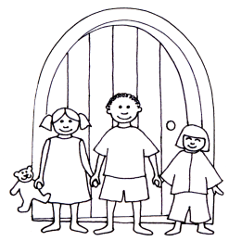
The Blue Door Nursery
Form 3
Long Term Health Care Plan

Name of Child:
Child’s Group:
Date of Birth:
Medical Diagnosis or Condition:
Date to Start From:
Review Date: (every 6 months)

Name of Medicine:
Strength of Medicine:
Form/Type of Medicine:
Expiry Date:
For non-prescribed medicines:
Has the medicine been administered without any YES / NO
adverse effects to the child in the past?
Describe Medical Needs and Details of Child’s Symptoms:

Daily Care Requirements: (e.g. before sport, at lunch time)

Describe what constitutes as an emergency for the child and the action to take if this happens:

Follow Up Care:

Name and Relation to Child:
Phone No: (work)
Phone No: (home)
Phone No: (mobile)
Name and Relation to Child:
Phone No: (work)
Phone No: (home)
Phone No: (mobile)

Family Contact Information

G.P Contact Information
Doctor Surgery:
Name of Doctor:
Phone No:

Clinic/ Hospital Contact
Name of Surgery:
Name of Doctor:
Phone No:

The above information is, to the best of my knowledge, accurate at the time of writing and I give consent to The Blue Door Nursery staff administering medicine in accordance with the setting’s policy. I will inform The Blue Door Nursery immediately, in writing, if there is any change of dosage or frequency of the medication or if the medicine is stopped.

Parent/Carer Signature:
Print Name:
Date:
Staff Signature:
Date:

